In the name of GOD

Ali Ansari - 916526639

Assignment 1

In this assignment, we aimed to plot a graph representing the students in our class who were enrolled in three different courses.

First, we converted the CSV file into a Pandas, which is easier to work with in Python.

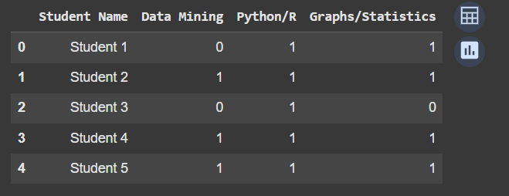

Next, we began creating our graph using the Pymnet library. We added the nodes and edges, and then we plotted the three-layer network required for the first question.

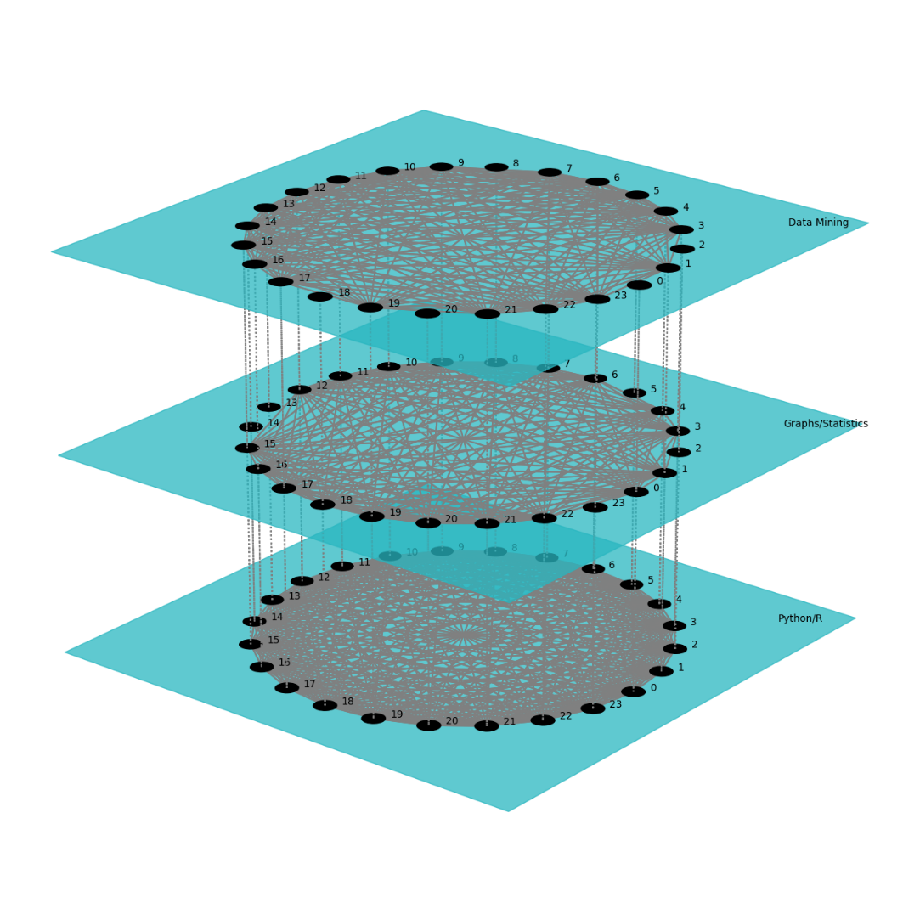

As we can see, all the students took Python course and it’s fully connected, however, the other ones are not.

After that, we go to the next question, which involved creating a weighted matrix. We began by adding the nodes and then incremented the weight of the edge by one each time two students were enrolled in the same course.

For plotting the graph, we utilized a red color map, where the intensity of red in the edges indicates the strength of the connection between two students. The more interconnected two students are, the deeper the red of their connecting edge will be.

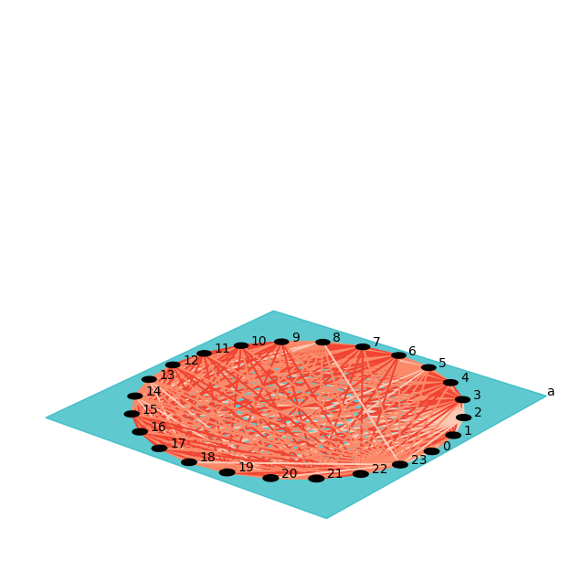

To visualize a bipartite network, I used NetworkX library since it’s a single layer matrix. Then I added the courses in one group and students in another one.

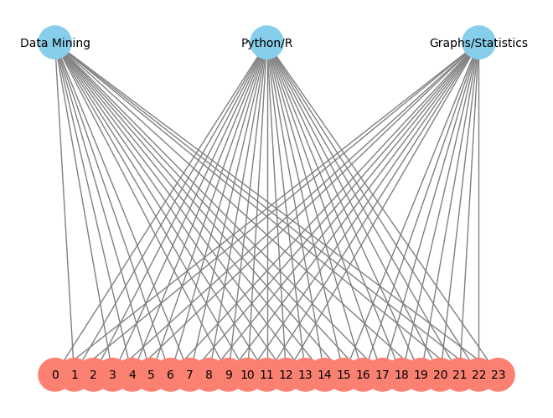

And for the analysis part, I created a function to calculate all the required information.

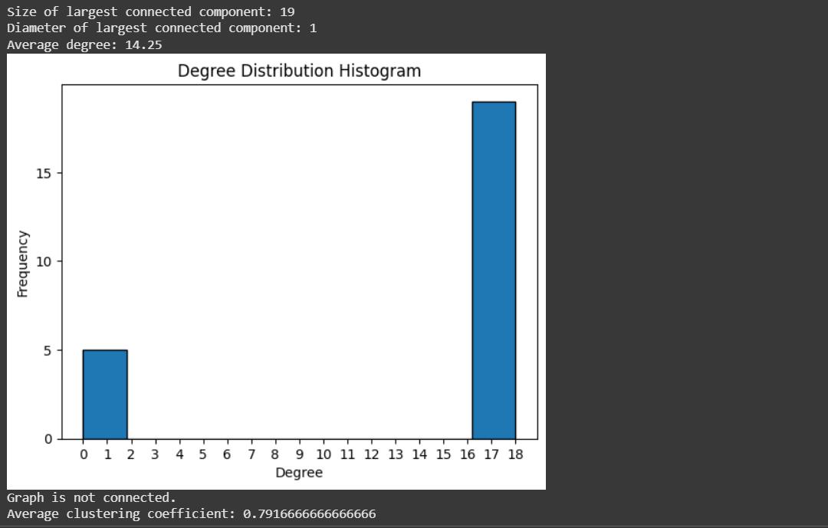

For Data mining and Graph course, results were similar since 5 students haven’t taken those courses. So, in those layers, we had a 19-node fully connected graph and 5 of them that are not connected.

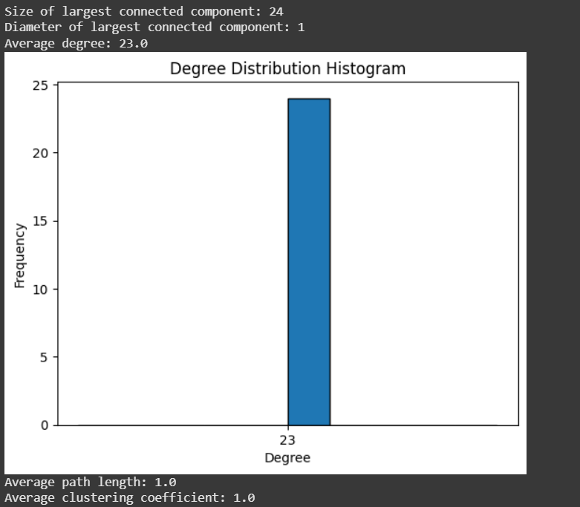

And for the Python course, our graph was fully connected.

Since all the students had python course before, the same applies to question 2, our weighted matrix, which is fully connected.